Ex. No. : 05 Date: 11-03-2026
Register No.: 231701023 Name: S.V.Jashwanth

Data Visualization App

Aim
Design and develop a mobile app that displays user data (e.g., steps, expenses) using custom-designed charts and graphs. Design Focus: Data visualization, clarity.

Procedure:
- Requirement Analysis
Develop an Android app to display daily expenses using bar, line, and pie charts for clear visualization.
- Create Project
Open Android Studio → New Project → Empty Activity → Select Kotlin → Set Minimum SDK (API 21+).
- Add Dependency
Add MPAndroidChart library in build.gradle and sync the project.
- Design UI
Use ScrollView + ConstraintLayout.
Add:
- Title TextView
- Summary TextViews (Total Expense, Highest Day)
- Spinner (day selection)
- EditText (amount input)
- Button (update)
- BarChart, LineChart, PieChart
- Initialize Data
Create list of days (Mon–Sun) and initialize expense values.
- Setup Spinner
Use ArrayAdapter to display day options.
- Configure Charts
Initialize charts, disable descriptions, set axis labels, and enable animations.
- Update Logic
Validate input → Get selected day → Update expense list.
- Bar Chart
Convert data to BarEntry → Set BarData → Refresh chart.
- Line Chart
Convert data to Entry → Set LineData → Customize and refresh.
- Pie Chart
Convert data to PieEntry → Set PieData → Show distribution.
- Update Summary
Calculate total expense and highest spending day → Display in TextViews.
- User Feedback
Clear input field and show Toast message.
- Testing
Run app → Enter values → Verify charts update correctly.
- Build & Run
Clean, rebuild, and execute the application.

AndroidManifest.xml

<?xml version="1.0" encoding="utf-8"?>
<manifest xmlns:android="http://schemas.android.com/apk/res/android"
xmlns:tools="http://schemas.android.com/tools">
<application
android:allowBackup="true"
android:dataExtractionRules="@xml/data_extraction_rules"
android:fullBackupContent="@xml/backup_rules"
android:icon="@mipmap/ic_launcher"
android:label="@string/app_name"
android:roundIcon="@mipmap/ic_launcher_round"
android:supportsRtl="true"
android:theme="@style/Theme.DataVisualizationApp">
<activity
android:name=".MainActivity"
android:exported="true">
<intent-filter>
<action android:name="android.intent.action.MAIN" />
<category android:name="android.intent.category.LAUNCHER" />
</intent-filter>
</activity>
</application>
</manifest>

Activity_main.xml

<?xml version="1.0" encoding="utf-8"?>
<androidx.coordinatorlayout.widget.CoordinatorLayout xmlns:android="http://schemas.android.com/apk/res/android"
xmlns:app="http://schemas.android.com/apk/res-auto"
xmlns:tools="http://schemas.android.com/tools"
android:layout_width="match_parent"
android:layout_height="match_parent"
android:background="?attr/colorSurface">
<com.google.android.material.appbar.AppBarLayout
android:layout_width="match_parent"
android:layout_height="wrap_content"
android:background="?attr/colorSurface">
<com.google.android.material.appbar.MaterialToolbar
android:id="@+id/toolbar"
android:layout_width="match_parent"
android:layout_height="?attr/actionBarSize"
app:title="Financial Dashboard"
app:titleCentered="true"
app:titleTextAppearance="@style/TextAppearance.Material3.TitleLarge" />
</com.google.android.material.appbar.AppBarLayout>
<androidx.core.widget.NestedScrollView
android:layout_width="match_parent"
android:layout_height="match_parent"
app:layout_behavior="@string/appbar_scrolling_view_behavior">
<LinearLayout
android:layout_width="match_parent"
android:layout_height="wrap_content"
android:orientation="vertical"
android:padding="16dp"
android:clipToPadding="false">
<!-- Summary Card -->
<com.google.android.material.card.MaterialCardView
android:layout_width="match_parent"
android:layout_height="wrap_content"
android:layout_marginBottom="16dp"
app:cardCornerRadius="16dp"
app:cardElevation="2dp"
app:strokeWidth="0dp">
<LinearLayout
android:layout_width="match_parent"
android:layout_height="wrap_content"
android:orientation="vertical"
android:padding="16dp">
<TextView
android:id="@+id/tvTotal"
android:layout_width="wrap_content"
android:layout_height="wrap_content"
android:text="Total Expense: $0"
android:textAppearance="@style/TextAppearance.Material3.HeadlineSmall"
android:textColor="?attr/colorPrimary" />
<TextView
android:id="@+id/tvHighest"
android:layout_width="wrap_content"
android:layout_height="wrap_content"
android:layout_marginTop="4dp"
android:text="Highest Spending Day: -"
android:textAppearance="@style/TextAppearance.Material3.BodyMedium"
android:alpha="0.7" />
</LinearLayout>
</com.google.android.material.card.MaterialCardView>
<!-- Input Card -->
<com.google.android.material.card.MaterialCardView
android:layout_width="match_parent"
android:layout_height="wrap_content"
android:layout_marginBottom="24dp"
app:cardCornerRadius="16dp"
app:cardElevation="2dp"
app:strokeWidth="0dp">
<androidx.constraintlayout.widget.ConstraintLayout
android:layout_width="match_parent"
android:layout_height="wrap_content"
android:padding="16dp">
<com.google.android.material.textfield.TextInputLayout
android:id="@+id/tilDay"
style="@style/Widget.Material3.TextInputLayout.OutlinedBox.ExposedDropdownMenu"
android:layout_width="0dp"
android:layout_height="wrap_content"
android:hint="@string/select_day"
app:layout_constraintEnd_toStartOf="@+id/tilAmount"
app:layout_constraintHorizontal_weight="1"
app:layout_constraintStart_toStartOf="parent"
app:layout_constraintTop_toTopOf="parent">
<AutoCompleteTextView
android:id="@+id/spinnerDay"
android:layout_width="match_parent"
android:layout_height="wrap_content"
android:inputType="none"
android:padding="16dp" />
</com.google.android.material.textfield.TextInputLayout>
<com.google.android.material.textfield.TextInputLayout
android:id="@+id/tilAmount"
style="@style/Widget.Material3.TextInputLayout.OutlinedBox"
android:layout_width="0dp"
android:layout_height="wrap_content"
android:layout_marginStart="12dp"
android:hint="@string/amount_hint"
app:layout_constraintEnd_toEndOf="parent"
app:layout_constraintHorizontal_weight="1"
app:layout_constraintStart_toEndOf="@+id/tilDay"
app:layout_constraintTop_toTopOf="parent"
app:prefixText="$">
<com.google.android.material.textfield.TextInputEditText
android:id="@+id/etAmount"
android:layout_width="match_parent"
android:layout_height="wrap_content"
android:inputType="numberDecimal" />
</com.google.android.material.textfield.TextInputLayout>
<com.google.android.material.button.MaterialButton
android:id="@+id/btnUpdate"
style="@style/Widget.Material3.Button"
android:layout_width="match_parent"
android:layout_height="wrap_content"
android:layout_marginTop="16dp"
android:text="@string/update_data"
app:layout_constraintTop_toBottomOf="@id/tilDay" />
</androidx.constraintlayout.widget.ConstraintLayout>
</com.google.android.material.card.MaterialCardView>
<!-- Bar Chart Card -->
<com.google.android.material.card.MaterialCardView
android:layout_width="match_parent"
android:layout_height="wrap_content"
android:layout_marginBottom="16dp"
app:cardCornerRadius="16dp"
app:cardElevation="2dp"
app:strokeWidth="0dp">
<LinearLayout
android:layout_width="match_parent"
android:layout_height="wrap_content"
android:orientation="vertical"
android:padding="16dp">
<TextView
android:layout_width="wrap_content"
android:layout_height="wrap_content"
android:text="@string/daily_expenses"
android:textAppearance="@style/TextAppearance.Material3.TitleMedium"
android:layout_marginBottom="8dp"/>
<com.github.mikephil.charting.charts.BarChart
android:id="@+id/barChart"
android:layout_width="match_parent"
android:layout_height="250dp" />
</LinearLayout>
</com.google.android.material.card.MaterialCardView>
<!-- Line Chart Card -->
<com.google.android.material.card.MaterialCardView
android:layout_width="match_parent"
android:layout_height="wrap_content"
android:layout_marginBottom="16dp"
app:cardCornerRadius="16dp"
app:cardElevation="2dp"
app:strokeWidth="0dp">
<LinearLayout
android:layout_width="match_parent"
android:layout_height="wrap_content"
android:orientation="vertical"
android:padding="16dp">
<TextView
android:layout_width="wrap_content"
android:layout_height="wrap_content"
android:text="@string/spending_trend"
android:textAppearance="@style/TextAppearance.Material3.TitleMedium"
android:layout_marginBottom="8dp"/>
<com.github.mikephil.charting.charts.LineChart
android:id="@+id/lineChart"
android:layout_width="match_parent"
android:layout_height="250dp" />
</LinearLayout>
</com.google.android.material.card.MaterialCardView>
<!-- Pie Chart Card -->
<com.google.android.material.card.MaterialCardView
android:layout_width="match_parent"
android:layout_height="wrap_content"
android:layout_marginBottom="32dp"
app:cardCornerRadius="16dp"
app:cardElevation="2dp"
app:strokeWidth="0dp">
<LinearLayout
android:layout_width="match_parent"
android:layout_height="wrap_content"
android:orientation="vertical"
android:padding="16dp">
<TextView
android:layout_width="wrap_content"
android:layout_height="wrap_content"
android:text="@string/expense_distribution"
android:textAppearance="@style/TextAppearance.Material3.TitleMedium"
android:layout_marginBottom="8dp"/>
<com.github.mikephil.charting.charts.PieChart
android:id="@+id/pieChart"
android:layout_width="match_parent"
android:layout_height="300dp" />
</LinearLayout>
</com.google.android.material.card.MaterialCardView>
</LinearLayout>
</androidx.core.widget.NestedScrollView>
</androidx.coordinatorlayout.widget.CoordinatorLayout>

MainActivity.kt

package com.example.datavisualizationapp
import android.graphics.Color
import android.os.Bundle
import android.view.View
import android.widget.*
import androidx.appcompat.app.AppCompatActivity
import androidx.core.graphics.toColorInt
import com.github.mikephil.charting.charts.*
import com.github.mikephil.charting.components.XAxis
import com.github.mikephil.charting.data.*
import com.github.mikephil.charting.formatter.IndexAxisValueFormatter
import com.github.mikephil.charting.utils.ColorTemplate
import com.google.android.material.textfield.MaterialAutoCompleteTextView
import java.util.Locale
class MainActivity : AppCompatActivity() {
private lateinit var barChart: BarChart
private lateinit var lineChart: LineChart
private lateinit var pieChart: PieChart
private lateinit var autoCompleteDay: MaterialAutoCompleteTextView
private lateinit var etAmount: EditText
private lateinit var tvTotal: TextView
private lateinit var tvHighest: TextView
private val days = listOf("Mon", "Tue", "Wed", "Thu", "Fri", "Sat", "Sun")
private val expenses = mutableListOf(120f, 180f, 90f, 250f, 300f, 140f, 200f)
override fun onCreate(savedInstanceState: Bundle?) {
super.onCreate(savedInstanceState)
setContentView(R.layout.activity_main)
initViews()
setupSpinner()
setupCharts()
updateCharts()
updateSummary()
findViewById<Button>(R.id.btnUpdate).setOnClickListener {
updateData()
}
}
private fun initViews() {
barChart = findViewById(R.id.barChart)
lineChart = findViewById(R.id.lineChart)
pieChart = findViewById(R.id.pieChart)
autoCompleteDay = findViewById(R.id.spinnerDay)
etAmount = findViewById(R.id.etAmount)
tvTotal = findViewById(R.id.tvTotal)
tvHighest = findViewById(R.id.tvHighest)
}
private fun setupSpinner() {
val adapter = ArrayAdapter(this, android.R.layout.simple_list_item_1, days)
autoCompleteDay.setAdapter(adapter)
autoCompleteDay.setText(days[0], false)
}
private fun setupCharts() {
// Shared Chart Styling
val charts = listOf(barChart, lineChart, pieChart)
charts.forEach { chart ->
chart.description.isEnabled = false
chart.legend.isEnabled = true
chart.animateY(1000)
}
// Bar Chart Styling
barChart.xAxis.apply {
valueFormatter = IndexAxisValueFormatter(days)
position = XAxis.XAxisPosition.BOTTOM
setDrawGridLines(false)
granularity = 1f
}
barChart.axisLeft.setDrawGridLines(false)
barChart.axisRight.isEnabled = false
// Line Chart Styling
lineChart.xAxis.apply {
valueFormatter = IndexAxisValueFormatter(days)
position = XAxis.XAxisPosition.BOTTOM
setDrawGridLines(false)
granularity = 1f
}
lineChart.axisLeft.setDrawGridLines(false)
lineChart.axisRight.isEnabled = false
// Pie Chart Styling
pieChart.isDrawHoleEnabled = true
pieChart.setHoleColor(Color.TRANSPARENT)
pieChart.setEntryLabelColor(Color.BLACK)
}
private fun updateData() {
val input = etAmount.text.toString()
val selectedDay = autoCompleteDay.text.toString()
if (input.isEmpty()) {
etAmount.error = getString(R.string.enter_amount)
return
}
val value = input.toFloatOrNull()
if (value == null || value < 0) {
etAmount.error = getString(R.string.invalid_amount)
return
}
val index = days.indexOf(selectedDay)
if (index != -1) {
expenses[index] = value
updateCharts()
updateSummary()
etAmount.text.clear()
etAmount.error = null
Toast.makeText(this, "Updated $selectedDay", Toast.LENGTH_SHORT).show()
}
}
private fun updateCharts() {
updateBarChart()
updateLineChart()
updatePieChart()
}
private fun updateBarChart() {
val entries = expenses.mapIndexed { i, v -> BarEntry(i.toFloat(), v) }
val dataSet = BarDataSet(entries, getString(R.string.daily_expenses))
dataSet.colors = ColorTemplate.MATERIAL_COLORS.toList()
dataSet.valueTextSize = 10f
barChart.data = BarData(dataSet)
barChart.invalidate()
}
private fun updateLineChart() {
val entries = expenses.mapIndexed { i, v -> Entry(i.toFloat(), v) }
val themeColor = "#6200EE".toColorInt()
val dataSet = LineDataSet(entries, getString(R.string.spending_trend)).apply {
color = themeColor
setCircleColor(themeColor)
lineWidth = 2f
circleRadius = 4f
setDrawCircleHole(true)
valueTextSize = 10f
setDrawFilled(true)
fillAlpha = 50
fillColor = themeColor
mode = LineDataSet.Mode.CUBIC_BEZIER
}
lineChart.data = LineData(dataSet)
lineChart.invalidate()
}
private fun updatePieChart() {
val entries = mutableListOf<PieEntry>()
expenses.forEachIndexed { i, v ->
if (v > 0) entries.add(PieEntry(v, days[i]))
}
val dataSet = PieDataSet(entries, "").apply {
colors = ColorTemplate.MATERIAL_COLORS.toList()
valueTextSize = 12f
valueTextColor = Color.BLACK
sliceSpace = 3f
}
pieChart.data = PieData(dataSet)
pieChart.centerText = "Expense\nBreakdown"
pieChart.setCenterTextSize(16f)
pieChart.invalidate()
}
private fun updateSummary() {
val total = expenses.sum()
val max = expenses.maxOrNull() ?: 0f
val index = expenses.indexOf(max)
val totalStr = String.format(Locale.US, "%.2f", total)
val maxStr = String.format(Locale.US, "%.2f", max)
tvTotal.text = getString(R.string.total_expense_format, totalStr)
tvHighest.text = getString(R.string.highest_spending_format, days[index], maxStr)
}
}

Output

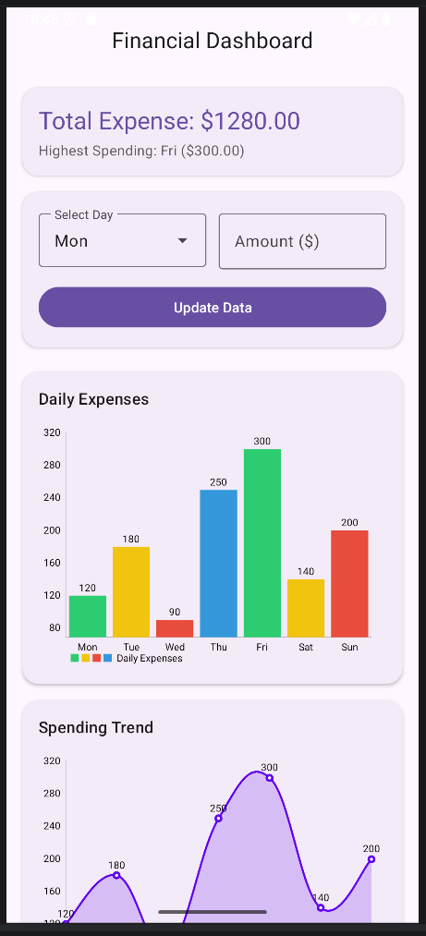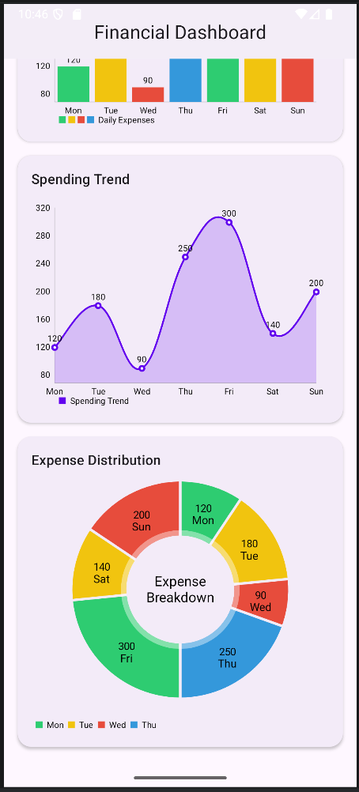

Result:
The Android application successfully displays and updates daily expense data using bar, line, and pie charts with accurate summary information.

